|  |  |
| --- | --- |
| KSU_logo.jpg | **King Saud University**  **College of Computer and Information Sciences**  **Department of Computer Science** |

**CSC 220: Computer Organization**

**Labwork - #3**

**Name: Saud Amer alkahtani,id:436102946,day:Sunday,Hour:4to6pm**

1. **Introduction**

In this lab-work we are going to see the advantage of simplification in the Boolean expressions so that we get a logic circuit with fewer gates.

1. **Experiments**

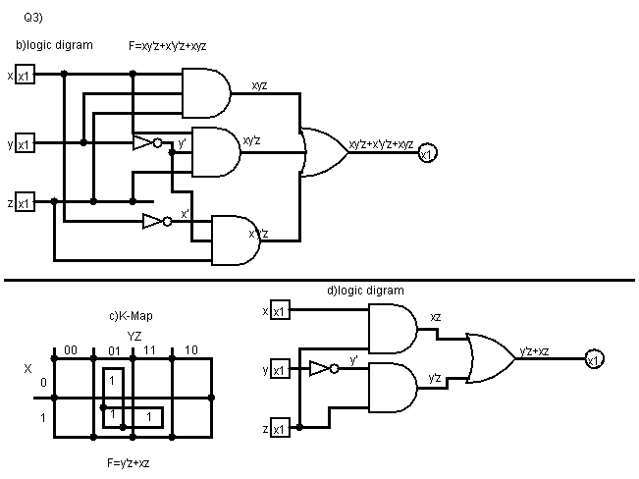

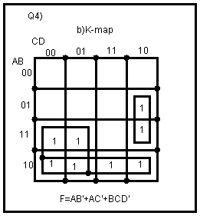

1. **Results**

**Q3:**

**a)**

truth table for non-simplified expression:

|  |  |  |  |  |  |  |
| --- | --- | --- | --- | --- | --- | --- |
| **x** | **y** | **z** | **xy’z** | **X’y’z** | **xyz** | **Xy’z+x’y’z+xyz** |
| **0** | **0** | **0** | **0** | **0** | **0** | **0** |
| **0** | **0** | **1** | **0** | **1** | **0** | **1** |
| **0** | **1** | **0** | **0** | **0** | **0** | **0** |
| **0** | **1** | **1** | **0** | **0** | **0** | **0** |
| **1** | **0** | **0** | **0** | **0** | **0** | **0** |
| **1** | **0** | **1** | **1** | **0** | **0** | **1** |
| **1** | **1** | **0** | **0** | **0** | **0** | **0** |
| **1** | **1** | **1** | **0** | **0** | **1** | **1** |

**d)**

truth table for simplified expression:

|  |  |  |  |  |  |
| --- | --- | --- | --- | --- | --- |
| **x** | **y** | **z** | **y’z** | **xz** | **y’z+xz** |
| **0** | **0** | **0** | **0** | **0** | **0** |
| **0** | **0** | **1** | **1** | **0** | **1** |
| **0** | **1** | **0** | **0** | **0** | **0** |
| **0** | **1** | **1** | **0** | **0** | **0** |
| **1** | **0** | **0** | **0** | **0** | **0** |
| **1** | **0** | **1** | **1** | **1** | **1** |
| **1** | **1** | **0** | **0** | **0** | **0** |
| **1** | **1** | **1** | **0** | **1** | **1** |

**e)**

we find that the output for the non-simplified and the simplified expressions are the same yet the number for gates for f1 is 4 but the number of gates for f2 is 3 gates only

Q4:

**a)**

truth table for the Boolean function

|  |  |  |  |  |
| --- | --- | --- | --- | --- |
| A | B | C | D | F |
| 0 | 0 | 0 | 0 | 0 |
| 0 | 0 | 0 | 1 | 0 |
| 0 | 0 | 1 | 0 | 0 |
| 0 | 0 | 1 | 1 | 0 |
| 0 | 1 | 0 | 0 | 0 |
| 0 | 1 | 0 | 1 | 0 |
| 0 | 1 | 1 | 0 | 1 |
| 0 | 1 | 1 | 1 | 0 |
| 1 | 0 | 0 | 0 | 1 |
| 1 | 0 | 0 | 1 | 1 |
| 1 | 0 | 1 | 0 | 1 |
| 1 | 0 | 1 | 1 | 1 |
| 1 | 1 | 0 | 0 | 1 |
| 1 | 1 | 0 | 1 | 1 |
| 1 | 1 | 1 | 0 | 1 |
| 1 | 1 | 1 | 1 | 0 |

**c)**

the simplified Boolean expression is : F=AB’+AC’+BCD’

1. **Discussion**

We see in this lab that with simplification we can get much simpler and cost efficient design for the complex circuits that we sometimes face.